
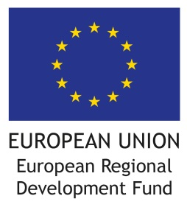
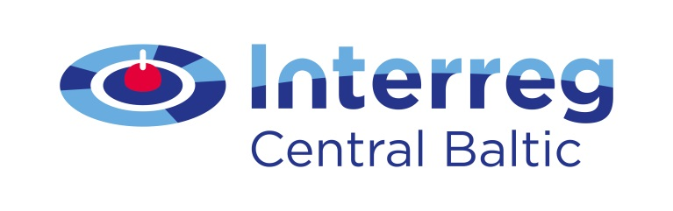

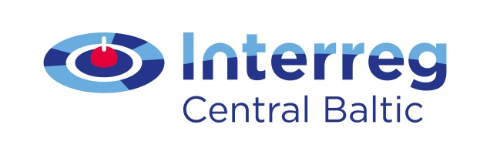
VALUES CREATED
IN COOPERATION!

The project 30MILES aims at:
The project 30MILES will result in:
The project is a joint cooperation venture of:
The project 30MILES (Small port every 30 miles apart – Development of services for lively water tourism in the Eastern Gulf of Finland) aims at improving the overall service level and safety in small ports and waterfront. The project idea is to organize small ports into a cooperating network at the distance of every 30 nautical miles in order to increase small ports attractiveness in the region. The environmental sustainability and green economy will be considered in all plans, recommendations, concepts and investments. Implementation period: 2015 – 2018.
In practice the 30MILES project establishes a ring of ports around the Eastern Gulf of Finland to focus on joint development of sustainable port services and marketing activities. Joint efforts are made to improve the services offered in small ports and help them receive better visibility from the potential visitors. Effective marketing is implemented to inform the visitors and create sustainability for local businesses. As a result of the project service level increases in 12 small ports in the Eastern Gulf of Finland. The new ring of ports creates an attractive entity, which is in the interest of boaters. The information about the services of the ports and accessibility is clearly presented. The improvements attract new businesses and investors, which in turn attract more visitors to the area.
Kotka Maritime Research Association, Finland | Kymenlaakso University of Applied Sciences, Finland | University of Helsinki, Finland |Cursor Ltd, Finland | Posintra Ltd, Finland | Ida-Viru Enterprise Centre, Estonia I Non-profit organisation of Eisma Harbor, Estonia IViimsi Municipality, Estonia I Estonian Maritime Museum, Estonia I Narva Department for City Development and Economy, Estonia I Narva-Jõesuu Municipality, Estonia
This is done with 3 301 745 euros from the European Regional Development Fund.
Find out more:
Anne Veevo, Project Coordinator Narva, anne.veevo@narva.ee |
http://www.narva.ee/en/for_tourists/project__“30_miles”/page:7860
http://www.merikotka.fi/projects/current-projects/30miles/

